**Sliders**

Following snapshot shows different sliders:

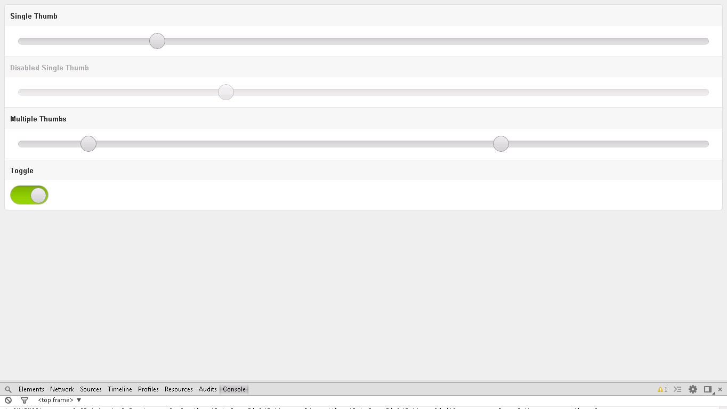

**Snapshot 1.1**

**Code**

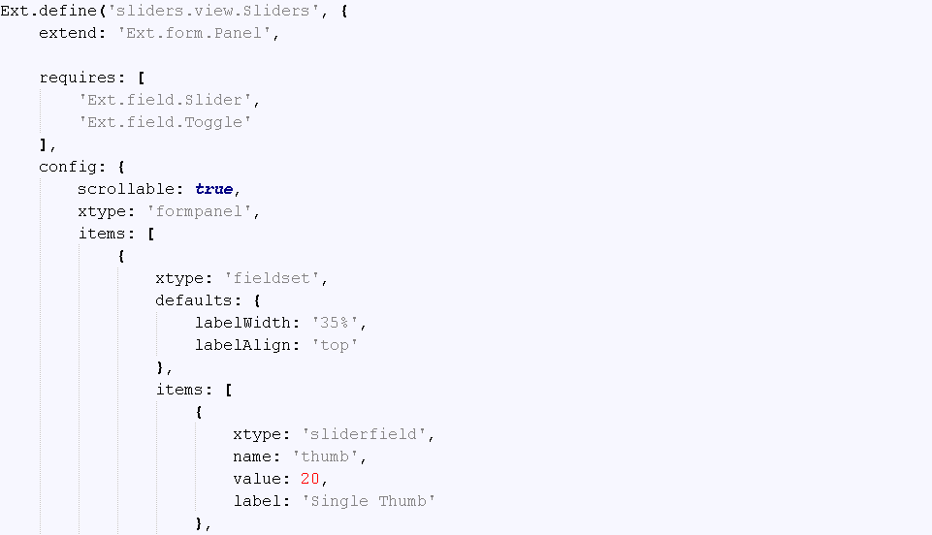

**Snapshot 1.2**

**Ext.define('sliders.view.Sliders',**:-> User defined Class is defined for Sliders

**{**

**extend: 'Ext.form.Panel', ,** :-> Extneds to Panel(Super class to use in your application)

**requires: [**

**'Ext.field.Slider',** :-> Slider class is required here to add slider in your application

**'Ext.field.Toggle'** :-> Toggle class is required here to add toggle in your application

**],**

**config: {**

**scrollable: true,**

**xtype: 'formpanel',** :-> To add formpanel

**items: [**

**{**

**xtype: 'fieldset',**

**defaults: {**

**labelWidth: '35%',**

**labelAlign: 'top'**

**},**

**items: [** :-> silder field is added to add single thumb slider in your application

**{**

**xtype: 'sliderfield',**

**name: 'thumb',**

**value: 20,**

**label: 'Single Thumb'**

**},**

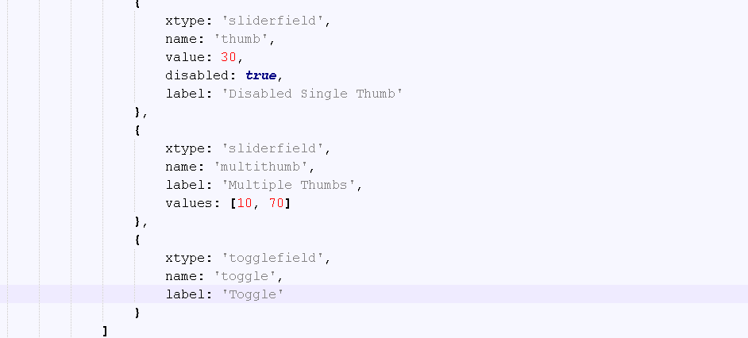

**Snapshot 1.3**

**{**

**xtype: 'sliderfield',** :-> silder field is added to add single thumb slider in your application

**name: 'thumb',**

**value: 30,**

**disabled: true,** :-> property is set to true

**label: 'Disabled Single Thumb'**

**},**

**{**

**xtype: 'sliderfield',** :-> silder field is added to add single thumb slider in your application

**name: 'multithumb',**

**label: 'Multiple Thumbs',**

**values: [10, 70]** :-> property to set two slides within one slider.

**},**

**{**

**xtype: 'togglefield',** :-> Toggle field is added to add toggle in application

**name: 'toggle',**

**label: 'Toggle'**

**}**

**FAQ**

1. Why spacer is used?

Ans: It is used to give specific space between items.

**Checkpoints:**

1. Check carefully with your indentations as if you will miss any of the braces by mistake may reflect in compilation error.
2. See that your .js file starts with Ext.Define block and check that ends at the end of the program.
3. More than one items are separated by comma (,) separator and main program block of define is ended by semi colon (;)
4. Any value is assigned using colon (:) for example ui: 'confirm' and value is written inside single coats.
5. Items block starts with square brackets [] , which contains multiple members and also sub items.
6. Don’t forget to add entries of your files in app.js.

**Source Code:**

